**A452 JavaScript**

**William Wood**

**7474**

**For June 2017**

**Task 4:**

**My plan for completing task 4:**I am going to reuse my code from task 3 for this task, removing the button and adding a time statement as well. This will ensure that the code is functional without any errors. I will then evaluate my code against the success criteria and fix or inprove any areas that do not meet the critera.

**Success Criteria:**  
In order to make a successful script I must:  
-Remove unnecicary code from task 3  
-Add a timing statement to advance the lights automatically.  
-Test the code to make sure that there are no issues.

**Screenshot of my code:**

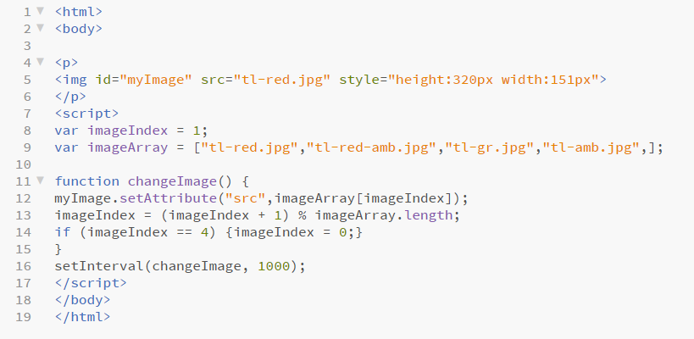

**A screenshot of the timing JavaScript:**



**Testing of the code:**

First traffic light:

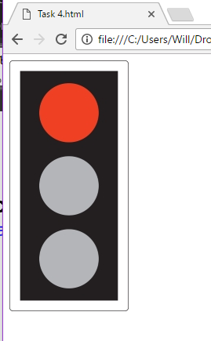

Second traffic light:

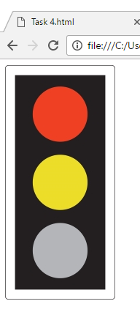

Third traffic light:

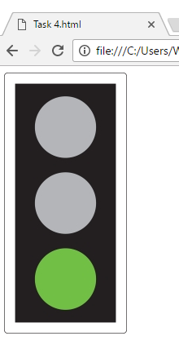

Fourth traffic light:

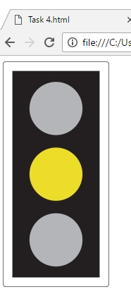

Back to the first traffic light (to show that the loop is working):

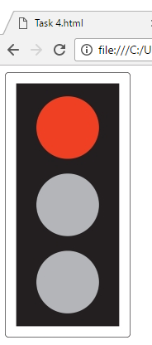

**Remedial action taken:**

I had to change the timing of the traffic lights because they were too fast at first. To do this I changed the “changeImage” value to 1000 instead of 100. This is shown below:



**Annotation of my code:**

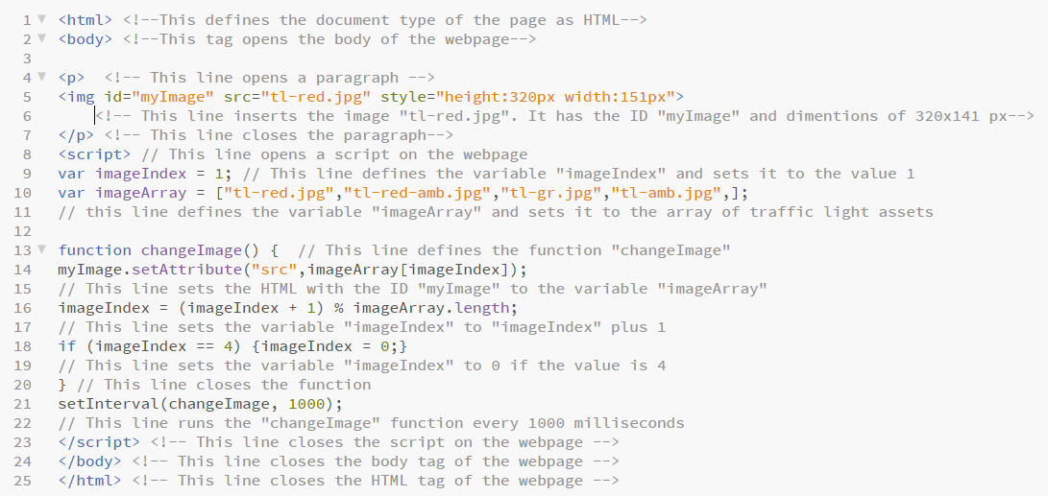

I annotated all of my HTML code using the comment tags **<!--** and **-->**. I also annotated all of my JavaScript code with “//”. This makes it easy for other people to see what each line of the code does in detail. This also helps with troubleshooting as you can clearly see what each tag does and how it works.

**Evaluation against the success criteria:**

|  |  |  |
| --- | --- | --- |
| **Criteria Point** | **How have I met the point?** | **Evidence** |
| Remove unneccicary code from task 3 | I removed the button because it was no longer needed. The lines highlighted in RED are the ones that I removed | **See below** |
| Add a timing statement to advance the light automatically | I added a “setInterval” statement that runs the function “changeImage” every 1000 milliseconds |  |
| Test the code to make sure that there are no issues | I tested my code above and fixed the timing of the traffic lights. | **See above** |

